Week 2
Assignment #2: “I am From Poem”

This week’s assignment is a bit different. You are going to write a poem, and then create a work of art to go with it. Your final product can be anything you want, a pencil drawing, a painting, a weaving, a digital drawing, a sculpture, a photograph.

Supplies you’ll need:

- PAPER (plain, lined, newspaper, wrapping paper, scrap paper, colored, WHATEVER YOU CAN FIND!)
- PENCIL OR PEN
- COLORING UNTENSIL (paint, markers, colored pencils, crayons, whatever!)

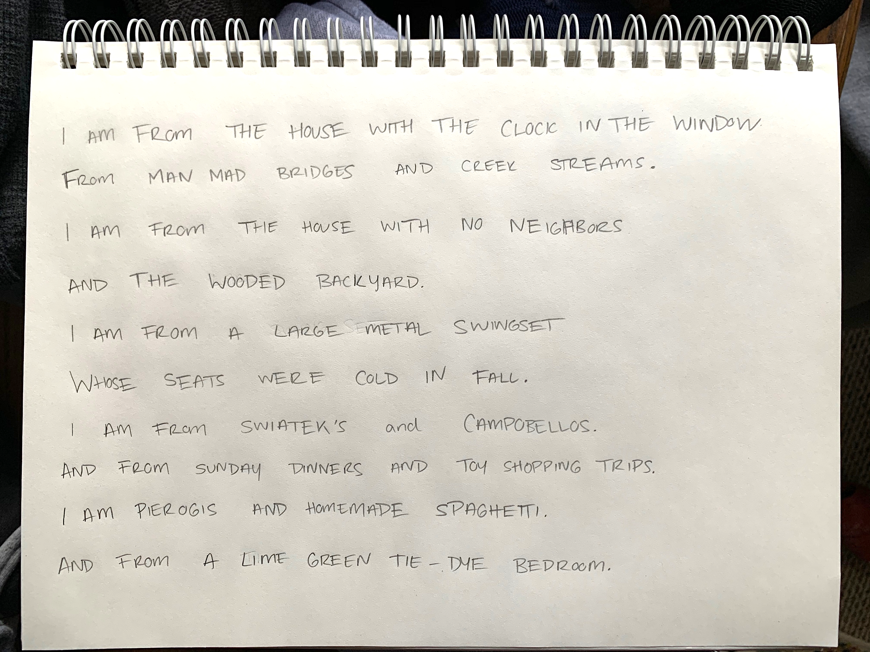
Step 1: WRITE YOUR POEM

In a Word Doc, Notes app, or even a separate sheet of paper, re-write the I AM FROM poem using your own personal information.

The Template is below. If you want to make changes while you’re writing it, that’s fine! You do you boo. ^^ My Example

“I Am From” Poem Template

I am from ______________________ (a specific item from your childhood home)
From _____________and ______________ (two objects or products of your past).
I am from ______________________ (a phrase describing your childhood home)
And ________________________ (more description of your childhood home).
I am from ___________________ (a plant, tree, or natural object from your past)
Whose _________________________ (describe that natural object)
I am from ______________________________ (two family names or ancestors)
And from _______________________________ (two family traits or traditions).
I am from ______________________ (two foods from your family history)
And from _________________________ (a memory of object you had as a child).

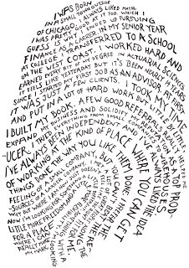
Step 2: CREATE YOUR ARTWORK
You are going to create an artwork based on your poem. How you choose to represent your poem is up to you!

- How do you want to express yourself?
- What material will you use?
- Will you use imagery?
- Will it be abstract?
- Not a fan of drawing? What you can build?
- Can you take a photograph of objects?
- Can you cut your poem up and piece it back together?

Having trouble starting? Try not to over think it!

PLEASE, Message me if you are stuck! I’d love to help

Step 3: REFLECT
- Why did you choose the materials you did (paint, photography, collage, etc.)?
- What do you like about your final artwork?
- What would you change about your artwork?
- Did you enjoy this assignment? Why or why not?

Step 4: SUBMIT WORK
Please send in your poem, a picture of your artwork, and your reflection. You can email these to me at cswiatek@nfschools.net or send them through the Remind app.

DUE WEDNESDAY 4/29

Examples:
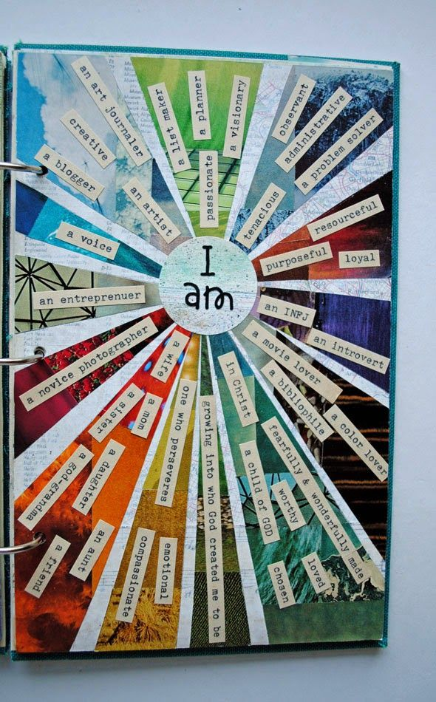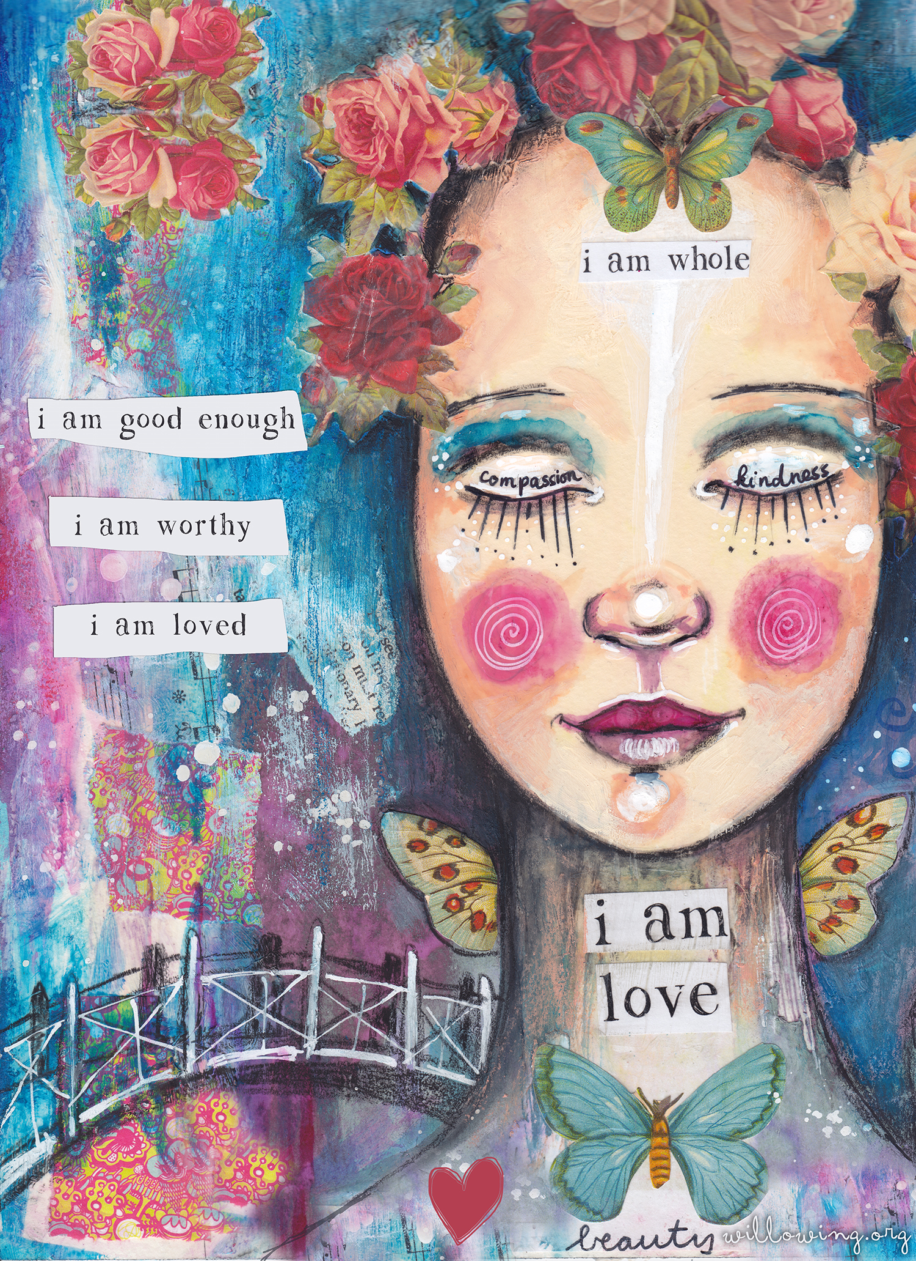
Word Collage Painting and Collage
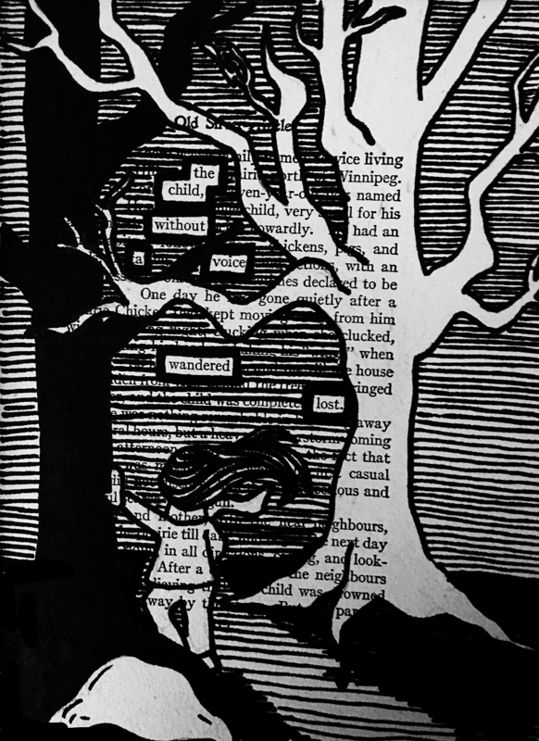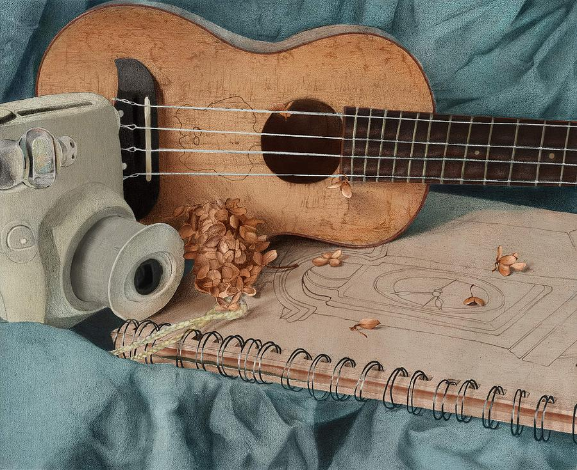
Blackout Poetry Photography

My Example:

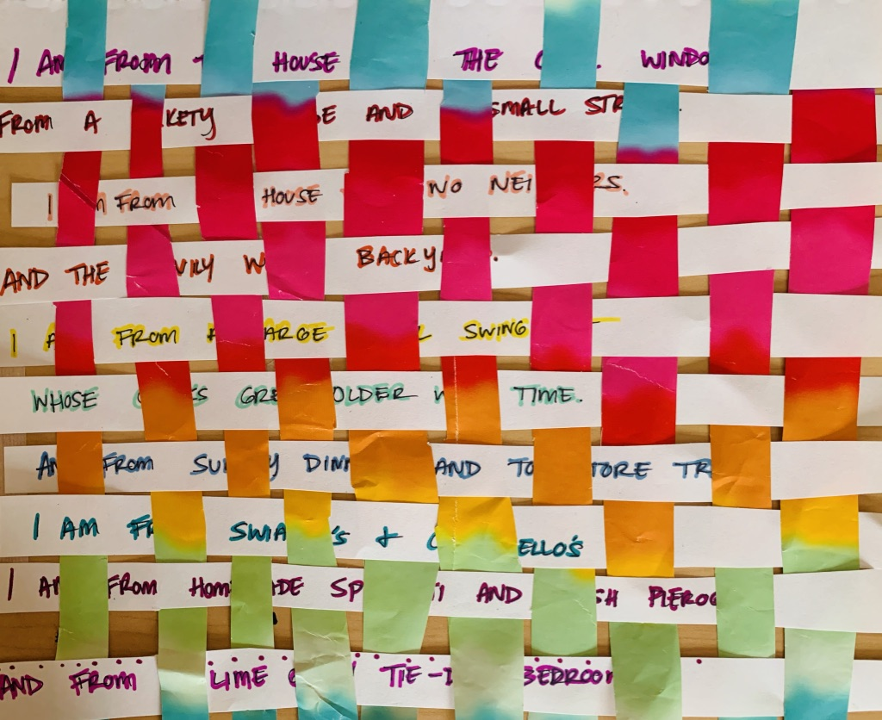
I wanted to try the weaved poem. I used a piece of wrapping paper I found around the house.
If this is something you would like to try, I will be posting how-to videos and resources on my Instagram this week (4/20 – 4/24).

